Задача: собрать и протестировать существующий проект с помощью Jenkins

1. Подготовить рабочее окружение (Java/.NET, Maven/MSBuild)

2. Сгенерировать SSH ключи (если у вас нет существующих)

3. Склонировать существующий тестовый проект с помощью git:https://github.com/vitalliuss/helloci (используется команда git clone, рекоммендуется git протокол)

4. Hастроить на своей или виртуальной машине Jenkins

5. Создать job, который будет компилировать проект

Джоба должна выполнять компиляцию проекта.

Settings

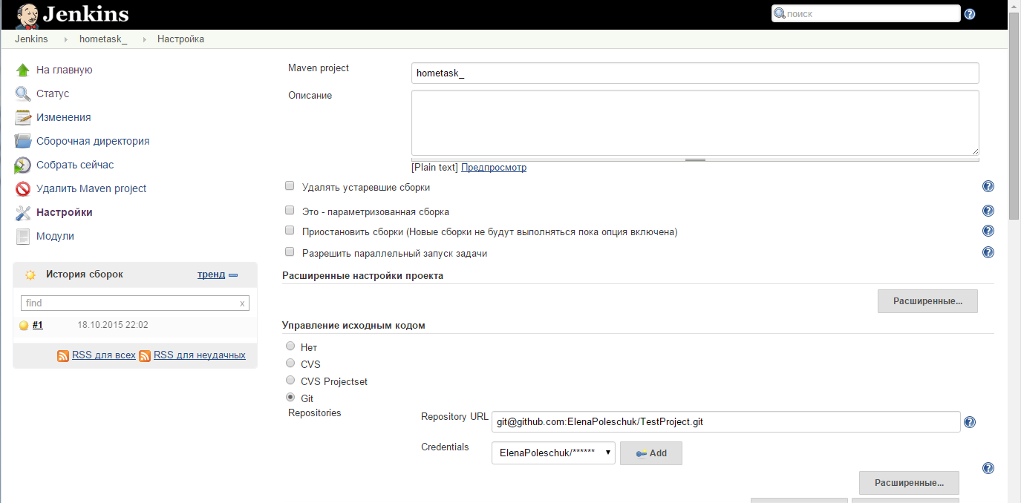

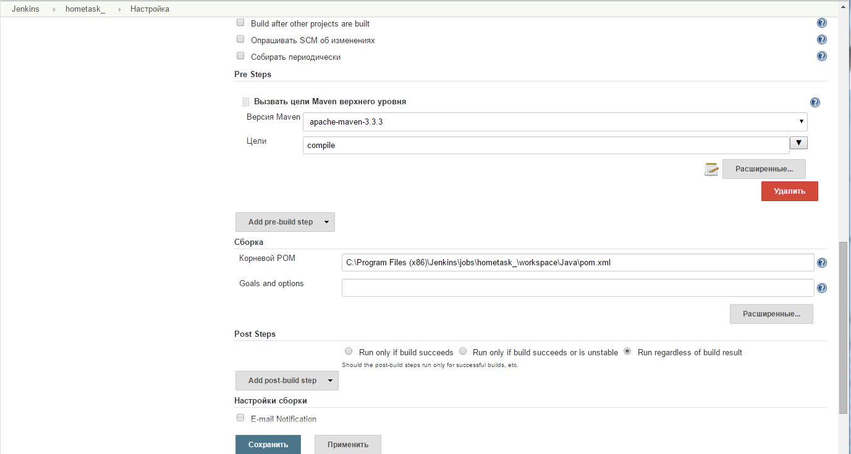

Test result

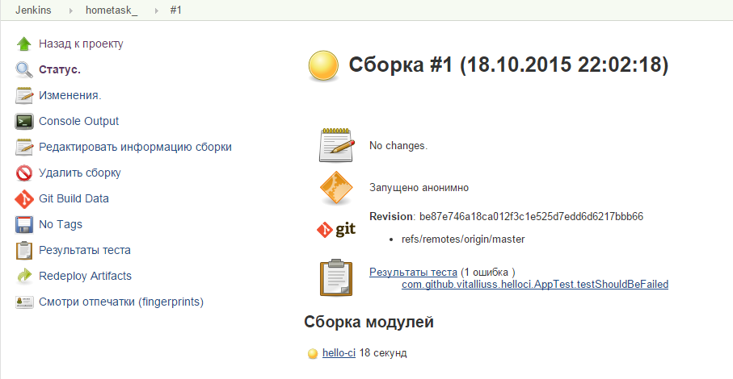

Error details:

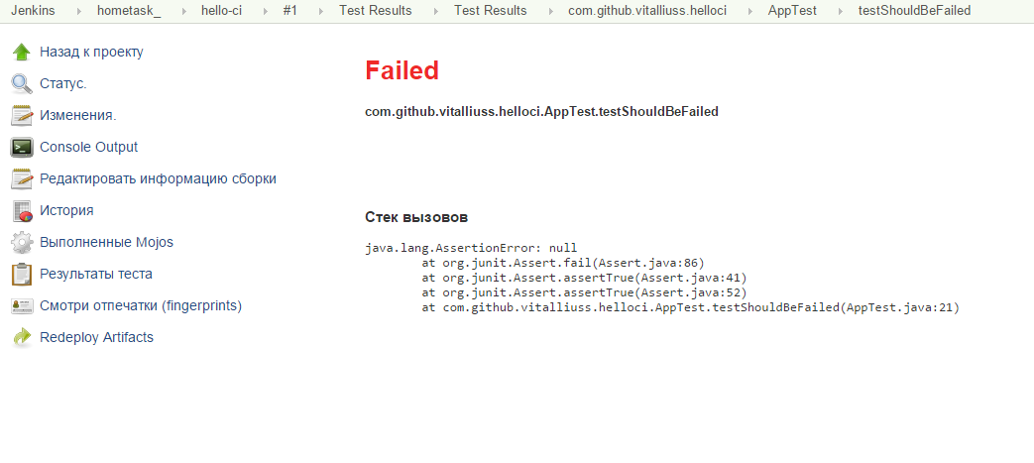

# НестабильныйВывод на консоль

Started by user [anonymous](http://localhost:8080/user/null)

Building in workspace C:\Program Files (x86)\Jenkins\jobs\hometask_\workspace

Cloning the remote Git repository

Cloning repository git@github.com:ElenaPoleschuk/TestProject.git

> D:\programs\Git\cmd\git.exe init C:\Program Files (x86)\Jenkins\jobs\hometask_\workspace # timeout=10

Fetching upstream changes from git@github.com:ElenaPoleschuk/TestProject.git

> D:\programs\Git\cmd\git.exe --version # timeout=10

> D:\programs\Git\cmd\git.exe -c core.askpass=true fetch --tags --progress git@github.com:ElenaPoleschuk/TestProject.git +refs/heads/*:refs/remotes/origin/*

> D:\programs\Git\cmd\git.exe config remote.origin.url git@github.com:ElenaPoleschuk/TestProject.git # timeout=10

> D:\programs\Git\cmd\git.exe config --add remote.origin.fetch +refs/heads/*:refs/remotes/origin/* # timeout=10

> D:\programs\Git\cmd\git.exe config remote.origin.url git@github.com:ElenaPoleschuk/TestProject.git # timeout=10

Fetching upstream changes from git@github.com:ElenaPoleschuk/TestProject.git

> D:\programs\Git\cmd\git.exe -c core.askpass=true fetch --tags --progress git@github.com:ElenaPoleschuk/TestProject.git +refs/heads/*:refs/remotes/origin/*

> D:\programs\Git\cmd\git.exe rev-parse "refs/remotes/origin/master^{commit}" # timeout=10

> D:\programs\Git\cmd\git.exe rev-parse "refs/remotes/origin/origin/master^{commit}" # timeout=10

Checking out Revision be87e746a18ca012f3c1e525d7edd6d6217bbb66 (refs/remotes/origin/master)

> D:\programs\Git\cmd\git.exe config core.sparsecheckout # timeout=10

> D:\programs\Git\cmd\git.exe checkout -f be87e746a18ca012f3c1e525d7edd6d6217bbb66

First time build. Skipping changelog.

[workspace] $ cmd.exe /C '""C:\Program Files (x86)\apache-maven-3.3.3\bin\mvn.cmd" -f "C:\Program Files (x86)\Jenkins\jobs\hometask\workspace\Java\pom.xml" compile && exit %%ERRORLEVEL%%"'

[INFO] Scanning for projects...

[INFO]

[INFO] ------------------------------------------------------------------------

[INFO] Building hello-ci 1.0-SNAPSHOT

[INFO] ------------------------------------------------------------------------

[INFO]

[INFO] **--- maven-resources-plugin:2.6:resources (default-resources) @ hello-ci ---**

**[WARNING] Using platform encoding (Cp1251 actually) to copy filtered resources, i.e. build is platform dependent!**

[INFO] skip non existing resourceDirectory C:\Program Files (x86)\Jenkins\jobs\hometask\workspace\Java\src\main\resources

[INFO]

[INFO] **--- maven-compiler-plugin:3.1:compile (default-compile) @ hello-ci ---**

[INFO] Nothing to compile - all classes are up to date

[INFO] ------------------------------------------------------------------------

[INFO] BUILD SUCCESS

[INFO] ------------------------------------------------------------------------

[INFO] Total time: 1.958 s

[INFO] Finished at: 2015-10-18T21:02:29+02:00

[INFO] Final Memory: 11M/92M

[INFO] ------------------------------------------------------------------------

Parsing POMs

Найден новый модуль com.github.vitalliuss.helloci:hello-ci hello-ci

Modules changed, recalculating dependency graph

[Java] $ "C:\Program Files\Java\jdk1.8.0_60\/bin/java" -cp "C:\Program Files (x86)\Jenkins\plugins\maven-plugin\WEB-INF\lib\maven31-agent-1.5.jar;C:\Program Files (x86)\apache-maven-3.3.3\boot\plexus-classworlds-2.5.2.jar;C:\Program Files (x86)\apache-maven-3.3.3/conf/logging" jenkins.maven3.agent.Maven31Main "C:\Program Files (x86)\apache-maven-3.3.3\" "C:\Program Files (x86)\Jenkins\war\WEB-INF\lib\remoting-2.52.jar" "C:\Program Files (x86)\Jenkins\plugins\maven-plugin\WEB-INF\lib\maven31-interceptor-1.5.jar" "C:\Program Files (x86)\Jenkins\plugins\maven-plugin\WEB-INF\lib\maven3-interceptor-commons-1.5.jar" 51652

<===[JENKINS REMOTING CAPACITY]===>channel started

Executing Maven: -B -f C:\Program Files (x86)\Jenkins\jobs\hometask\workspace\Java\pom.xml install

[INFO] Scanning for projects...

[INFO]

[INFO] ------------------------------------------------------------------------

[INFO] Building hello-ci 1.0-SNAPSHOT

[INFO] ------------------------------------------------------------------------

[INFO]

[INFO] **--- maven-resources-plugin:2.6:resources (default-resources) @ hello-ci ---**

**[WARNING] Using platform encoding (Cp1251 actually) to copy filtered resources, i.e. build is platform dependent!**

[INFO] skip non existing resourceDirectory C:\Program Files (x86)\Jenkins\jobs\hometask\workspace\Java\src\main\resources

[INFO]

[INFO] **--- maven-compiler-plugin:3.1:compile (default-compile) @ hello-ci ---**

[INFO] Nothing to compile - all classes are up to date

[INFO]

[INFO] **--- maven-resources-plugin:2.6:testResources (default-testResources) @ hello-ci ---**

**[WARNING] Using platform encoding (Cp1251 actually) to copy filtered resources, i.e. build is platform dependent!**

[INFO] skip non existing resourceDirectory C:\Program Files (x86)\Jenkins\jobs\hometask\workspace\Java\src\test\resources

[INFO]

[INFO] **--- maven-compiler-plugin:3.1:testCompile (default-testCompile) @ hello-ci ---**

[INFO] Nothing to compile - all classes are up to date

[INFO]

[INFO] **--- maven-surefire-plugin:2.16:test (default-test) @ hello-ci ---**

[INFO] Surefire report directory: C:\Program Files (x86)\Jenkins\jobs\hometask\workspace\Java\target\surefire-reports

[INFO] Using configured provider org.apache.maven.surefire.junit4.JUnit4Provider

-------------------------------------------------------

T E S T S

-------------------------------------------------------

Running com.github.vitalliuss.helloci.AppTest

Tests run: 5, Failures: 1, Errors: 0, Skipped: 1, Time elapsed: 0.152 sec <<< FAILURE! - in com.github.vitalliuss.helloci.AppTest

testShouldBeFailed(com.github.vitalliuss.helloci.AppTest) Time elapsed: 0.011 sec <<< FAILURE!

java.lang.AssertionError: null

at org.junit.Assert.fail(Assert.java:86)

at org.junit.Assert.assertTrue(Assert.java:41)

at org.junit.Assert.assertTrue(Assert.java:52)

at com.github.vitalliuss.helloci.AppTest.testShouldBeFailed(AppTest.java:21)

Results :

Failed tests:

AppTest.testShouldBeFailed:21 null

Tests run: 5, Failures: 1, Errors: 0, Skipped: 1

**[ERROR] There are test failures.**

Please refer to C:\Program Files (x86)\Jenkins\jobs\hometask\workspace\Java\target\surefire-reports for the individual test results.

[JENKINS] Recording test results

[INFO]

[INFO] **--- maven-jar-plugin:2.4:jar (default-jar) @ hello-ci ---**

[INFO]

[INFO] **--- maven-assembly-plugin:2.4:single (default) @ hello-ci ---**

[INFO] Building jar: C:\Program Files (x86)\Jenkins\jobs\hometask\workspace\Java\target\hello-ci-1.0-SNAPSHOT-jar-with-dependencies.jar

[INFO]

[INFO] >>> cobertura-maven-plugin:2.5.1:cobertura (default) > [cobertura]test @ hello-ci >>>

[INFO]

[INFO] **--- maven-resources-plugin:2.6:resources (default-resources) @ hello-ci ---**

**[WARNING] Using platform encoding (Cp1251 actually) to copy filtered resources, i.e. build is platform dependent!**

[INFO] skip non existing resourceDirectory C:\Program Files (x86)\Jenkins\jobs\hometask\workspace\Java\src\main\resources

[INFO]

[INFO] **--- maven-compiler-plugin:3.1:compile (default-compile) @ hello-ci ---**

[INFO] Nothing to compile - all classes are up to date

[INFO]

[INFO] **--- cobertura-maven-plugin:2.5.1:instrument (default) @ hello-ci ---**

[INFO] Cobertura 1.9.4.1 - GNU GPL License (NO WARRANTY) - See COPYRIGHT file

Cobertura: Loaded information on 2 classes.

Instrumenting 2 files to C:\Program Files (x86)\Jenkins\jobs\hometask\workspace\Java\target\generated-classes\cobertura

Cobertura: Saved information on 2 classes.

Instrument time: 274ms

[INFO] Instrumentation was successful.

[INFO] NOT adding cobertura ser file to attached artifacts list.

[INFO]

[INFO] **--- maven-resources-plugin:2.6:testResources (default-testResources) @ hello-ci ---**

**[WARNING] Using platform encoding (Cp1251 actually) to copy filtered resources, i.e. build is platform dependent!**

[INFO] skip non existing resourceDirectory C:\Program Files (x86)\Jenkins\jobs\hometask\workspace\Java\src\test\resources

[INFO]

[INFO] **--- maven-compiler-plugin:3.1:testCompile (default-testCompile) @ hello-ci ---**

[INFO] Nothing to compile - all classes are up to date

[INFO]

[INFO] **--- maven-surefire-plugin:2.16:test (default-test) @ hello-ci ---**

[INFO] Surefire report directory: C:\Program Files (x86)\Jenkins\jobs\hometask\workspace\Java\target\surefire-reports

[INFO] Using configured provider org.apache.maven.surefire.junit4.JUnit4Provider

-------------------------------------------------------

T E S T S

-------------------------------------------------------

Running com.github.vitalliuss.helloci.AppTest

Tests run: 5, Failures: 1, Errors: 0, Skipped: 1, Time elapsed: 0.206 sec <<< FAILURE! - in com.github.vitalliuss.helloci.AppTest

testShouldBeFailed(com.github.vitalliuss.helloci.AppTest) Time elapsed: 0.015 sec <<< FAILURE!

java.lang.AssertionError: null

at org.junit.Assert.fail(Assert.java:86)

at org.junit.Assert.assertTrue(Assert.java:41)

at org.junit.Assert.assertTrue(Assert.java:52)

at com.github.vitalliuss.helloci.AppTest.testShouldBeFailed(AppTest.java:21)

Flushing results...

Flushing results done

Cobertura: Loaded information on 2 classes.

Cobertura: Saved information on 2 classes.

Results :

Failed tests:

AppTest.testShouldBeFailed:21 null

Tests run: 5, Failures: 1, Errors: 0, Skipped: 1

**[ERROR] There are test failures.**

Please refer to C:\Program Files (x86)\Jenkins\jobs\hometask\workspace\Java\target\surefire-reports for the individual test results.

[JENKINS] Recording test results

[INFO]

[INFO] <<< cobertura-maven-plugin:2.5.1:cobertura (default) < [cobertura]test @ hello-ci <<<

[INFO]

[INFO] **--- cobertura-maven-plugin:2.5.1:cobertura (default) @ hello-ci ---**

[INFO] Cobertura 1.9.4.1 - GNU GPL License (NO WARRANTY) - See COPYRIGHT file

Cobertura: Loaded information on 2 classes.

Report time: 237ms

[INFO] Cobertura Report generation was successful.

[INFO]

[INFO] **--- maven-install-plugin:2.4:install (default-install) @ hello-ci ---**

[INFO] Installing C:\Program Files (x86)\Jenkins\jobs\hometask\workspace\Java\target\hello-ci-1.0-SNAPSHOT.jar to C:\Windows\system32\config\systemprofile\.m2\repository\com\github\vitalliuss\helloci\hello-ci\1.0-SNAPSHOT\hello-ci-1.0-SNAPSHOT.jar

[INFO] Installing C:\Program Files (x86)\Jenkins\jobs\hometask\workspace\Java\pom.xml to C:\Windows\system32\config\systemprofile\.m2\repository\com\github\vitalliuss\helloci\hello-ci\1.0-SNAPSHOT\hello-ci-1.0-SNAPSHOT.pom

[INFO] Installing C:\Program Files (x86)\Jenkins\jobs\hometask\workspace\Java\target\hello-ci-1.0-SNAPSHOT-jar-with-dependencies.jar to C:\Windows\system32\config\systemprofile\.m2\repository\com\github\vitalliuss\helloci\hello-ci\1.0-SNAPSHOT\hello-ci-1.0-SNAPSHOT-jar-with-dependencies.jar

[INFO] ------------------------------------------------------------------------

[INFO] BUILD SUCCESS

[INFO] ------------------------------------------------------------------------

[INFO] Total time: 19.136 s

[INFO] Finished at: 2015-10-18T21:02:56+02:00

[INFO] Final Memory: 22M/180M

[INFO] ------------------------------------------------------------------------

[JENKINS] Archiving C:\Program Files (x86)\Jenkins\jobs\hometask\workspace\Java\pom.xml to com.github.vitalliuss.helloci/hello-ci/1.0-SNAPSHOT/hello-ci-1.0-SNAPSHOT.pom

[JENKINS] Archiving C:\Program Files (x86)\Jenkins\jobs\hometask\workspace\Java\target\hello-ci-1.0-SNAPSHOT.jar to com.github.vitalliuss.helloci/hello-ci/1.0-SNAPSHOT/hello-ci-1.0-SNAPSHOT.jar

[JENKINS] Archiving C:\Program Files (x86)\Jenkins\jobs\hometask\workspace\Java\target\hello-ci-1.0-SNAPSHOT-jar-with-dependencies.jar to com.github.vitalliuss.helloci/hello-ci/1.0-SNAPSHOT/hello-ci-1.0-SNAPSHOT-jar-with-dependencies.jar

channel stopped

Finished: UNSTABLE

Задача повышенной сложности №1: выполнить запуск тестов проекта helloci и опубликовать результаты в jenkins. Запуск тестов можно осуществить с помощью mvn test для java и nunit-console для .net

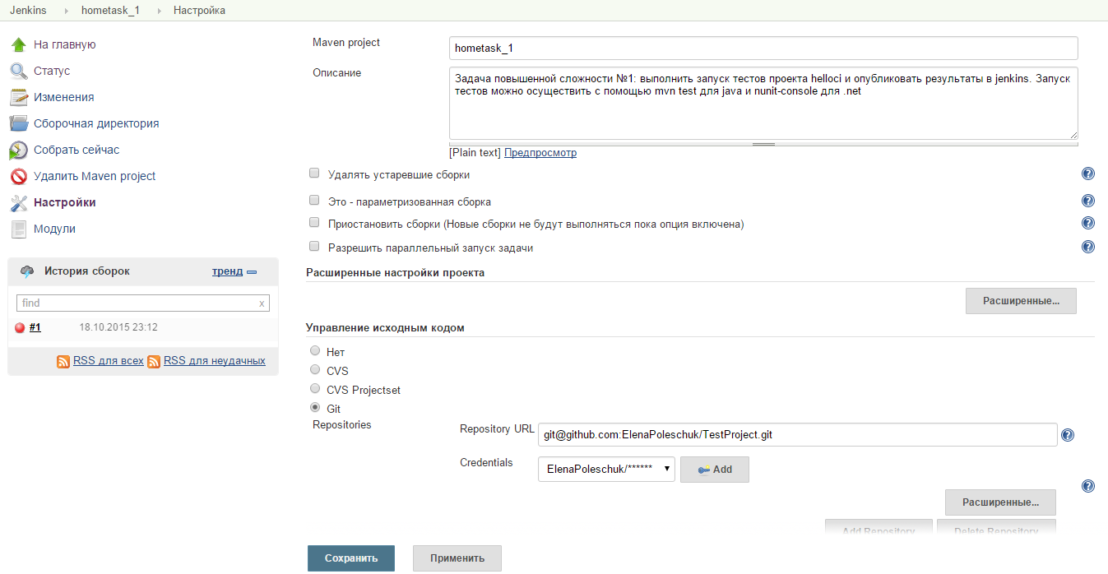

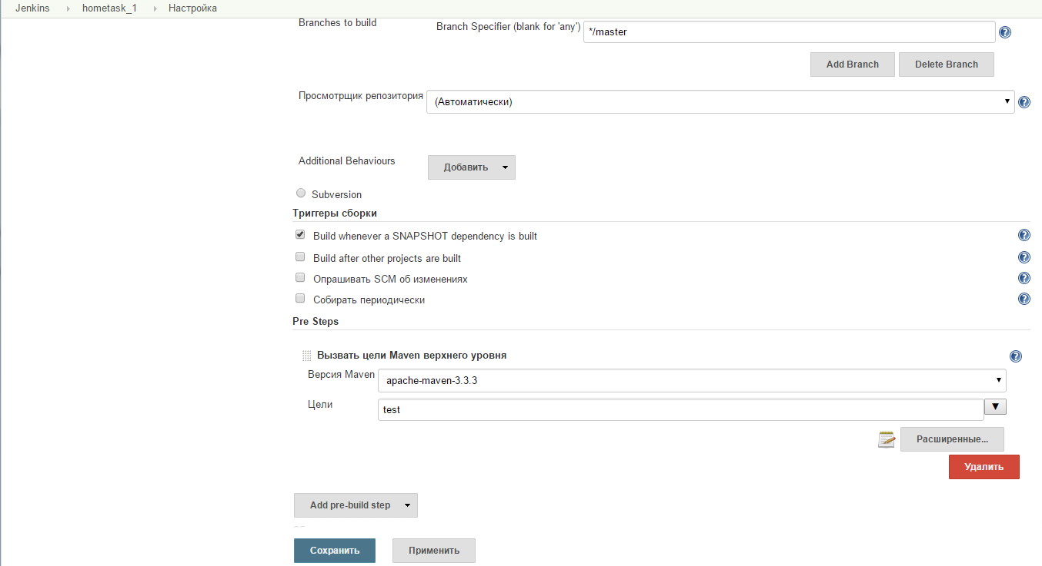

Result:

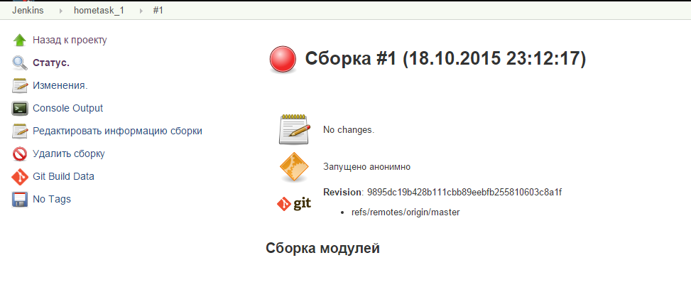

**Вывод на консоль**

Started by user [anonymous](http://localhost:8080/user/null)

Building in workspace C:\Program Files (x86)\Jenkins\jobs\hometask_1\workspace

Cloning the remote Git repository

Cloning repository git@github.com:ElenaPoleschuk/TestProject.git

> D:\programs\Git\cmd\git.exe init C:\Program Files (x86)\Jenkins\jobs\hometask_1\workspace # timeout=10

Fetching upstream changes from git@github.com:ElenaPoleschuk/TestProject.git

> D:\programs\Git\cmd\git.exe --version # timeout=10

> D:\programs\Git\cmd\git.exe -c core.askpass=true fetch --tags --progress git@github.com:ElenaPoleschuk/TestProject.git +refs/heads/*:refs/remotes/origin/*

> D:\programs\Git\cmd\git.exe config remote.origin.url git@github.com:ElenaPoleschuk/TestProject.git # timeout=10

> D:\programs\Git\cmd\git.exe config --add remote.origin.fetch +refs/heads/*:refs/remotes/origin/* # timeout=10

> D:\programs\Git\cmd\git.exe config remote.origin.url git@github.com:ElenaPoleschuk/TestProject.git # timeout=10

Fetching upstream changes from git@github.com:ElenaPoleschuk/TestProject.git

> D:\programs\Git\cmd\git.exe -c core.askpass=true fetch --tags --progress git@github.com:ElenaPoleschuk/TestProject.git +refs/heads/*:refs/remotes/origin/*

> D:\programs\Git\cmd\git.exe rev-parse "refs/remotes/origin/master^{commit}" # timeout=10

> D:\programs\Git\cmd\git.exe rev-parse "refs/remotes/origin/origin/master^{commit}" # timeout=10

Checking out Revision 9895dc19b428b111cbb89eebfb255810603c8a1f (refs/remotes/origin/master)

> D:\programs\Git\cmd\git.exe config core.sparsecheckout # timeout=10

> D:\programs\Git\cmd\git.exe checkout -f 9895dc19b428b111cbb89eebfb255810603c8a1f

First time build. Skipping changelog.

[workspace] $ cmd.exe /C '""C:\Program Files (x86)\apache-maven-3.3.3\bin\mvn.cmd" -f "C:\Program Files (x86)\Jenkins\jobs\hometask_1\workspace\Java\pom.xml" test && exit %%ERRORLEVEL%%"'

[INFO] Scanning for projects...

[INFO]

[INFO] ------------------------------------------------------------------------

[INFO] Building hello-ci 1.0-SNAPSHOT

[INFO] ------------------------------------------------------------------------

[INFO]

[INFO] **--- maven-resources-plugin:2.6:resources (default-resources) @ hello-ci ---**

**[WARNING] Using platform encoding (Cp1251 actually) to copy filtered resources, i.e. build is platform dependent!**

[INFO] skip non existing resourceDirectory C:\Program Files (x86)\Jenkins\jobs\hometask_1\workspace\Java\src\main\resources

[INFO]

[INFO] **--- maven-compiler-plugin:3.1:compile (default-compile) @ hello-ci ---**

[INFO] Changes detected - recompiling the module!

**[WARNING] File encoding has not been set, using platform encoding Cp1251, i.e. build is platform dependent!**

[INFO] Compiling 2 source files to C:\Program Files (x86)\Jenkins\jobs\hometask_1\workspace\Java\target\classes

[INFO]

[INFO] **--- maven-resources-plugin:2.6:testResources (default-testResources) @ hello-ci ---**

**[WARNING] Using platform encoding (Cp1251 actually) to copy filtered resources, i.e. build is platform dependent!**

[INFO] skip non existing resourceDirectory C:\Program Files (x86)\Jenkins\jobs\hometask_1\workspace\Java\src\test\resources

[INFO]

[INFO] **--- maven-compiler-plugin:3.1:testCompile (default-testCompile) @ hello-ci ---**

[INFO] Changes detected - recompiling the module!

**[WARNING] File encoding has not been set, using platform encoding Cp1251, i.e. build is platform dependent!**

[INFO] Compiling 1 source file to C:\Program Files (x86)\Jenkins\jobs\hometask_1\workspace\Java\target\test-classes

[INFO]

[INFO] **--- maven-surefire-plugin:2.16:test (default-test) @ hello-ci ---**

[INFO] Surefire report directory: C:\Program Files (x86)\Jenkins\jobs\hometask_1\workspace\Java\target\surefire-reports

[INFO] Using configured provider org.apache.maven.surefire.junit4.JUnit4Provider

-------------------------------------------------------

T E S T S

-------------------------------------------------------

Running com.github.vitalliuss.helloci.AppTest

Tests run: 5, Failures: 1, Errors: 0, Skipped: 1, Time elapsed: 0.213 sec <<< FAILURE! - in com.github.vitalliuss.helloci.AppTest

testShouldBeFailed(com.github.vitalliuss.helloci.AppTest) Time elapsed: 0.014 sec <<< FAILURE!

java.lang.AssertionError: null

at org.junit.Assert.fail(Assert.java:86)

at org.junit.Assert.assertTrue(Assert.java:41)

at org.junit.Assert.assertTrue(Assert.java:52)

at com.github.vitalliuss.helloci.AppTest.testShouldBeFailed(AppTest.java:21)

Results :

Failed tests:

AppTest.testShouldBeFailed:21 null

Tests run: 5, Failures: 1, Errors: 0, Skipped: 1

[INFO] ------------------------------------------------------------------------

[INFO] BUILD FAILURE

[INFO] ------------------------------------------------------------------------

[INFO] Total time: 11.959 s

[INFO] Finished at: 2015-10-18T22:12:44+02:00

[INFO] Final Memory: 14M/123M

[INFO] ------------------------------------------------------------------------

**[ERROR] Failed to execute goal org.apache.maven.plugins:maven-surefire-plugin:2.16:test (default-test) on project hello-ci: There are test failures.**

**[ERROR]**

**[ERROR] Please refer to C:\Program Files (x86)\Jenkins\jobs\hometask_1\workspace\Java\target\surefire-reports for the individual test results.**

**[ERROR] -> [Help 1]**

**[ERROR]**

**[ERROR] To see the full stack trace of the errors, re-run Maven with the -e switch.**

**[ERROR] Re-run Maven using the -X switch to enable full debug logging.**

**[ERROR]**

**[ERROR] For more information about the errors and possible solutions, please read the following articles:**

**[ERROR] [Help 1]** [**http://cwiki.apache.org/confluence/display/MAVEN/MojoFailureException**](http://cwiki.apache.org/confluence/display/MAVEN/MojoFailureException)

Build step 'Вызвать цели Maven верхнего уровня ' marked build as failure

Finished: FAILURE